Virtusa React Training

B Sahil (221910304005)

Day 5

Que. In functional component, create one state called data. Initialize the value of the data as “GITAM”. Create a button “Click” whenever we click on button, the value of the data needs to be changed to “GITAM HYDERABAD”.





App.js

import React from 'react'

import './App.css'

import { useState } from 'react'

export default function App() {

  const [data, setdata] = useState("Gitam")

  function update(){

    setdata("Gitam Hyderabad")

  }

  return (

    <div>

      <h1>{data}</h1>

      <button onClick={update}>Click Me</button>

    </div>

  )

}

------------------------------------------------------------------------------------React Props

Props stand for "**Properties**." They are **read-only** components. It is an object which stores the value of attributes of a tag and work similar to the HTML attributes. It gives a way to pass data from one component to other components. It is similar to function arguments. Props are passed to the component in the same way as arguments passed in a function.

Props are **immutable** so we cannot modify the props from inside the component. Inside the components, we can add attributes called props. These attributes are available in the component as **this.props** and can be used to render dynamic data in our render method.

Example: -

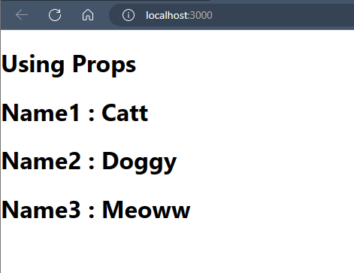

App.js

import React from 'react'

import Personal from './Personal'

export default function App() {

  return (

    <div>

      <h1> Using Props </h1>

      <Personal Name1={"Catt"}

      Name2={"Doggy"}

      Name3={"Meoww"} />

    </div>

  )

}

Personal.js

import React from 'react'

export default function Personal(Props) {

  return (

    <div>

        <h1>Name1 : {Props.Name1}</h1>

        <h1>Name2 : {Props.Name2}</h1>

        <h1>Name3 : {Props.Name3}</h1>

    </div>

  )

}

Assignment:

1.Create a function called GITAM_YOURNAME and pass the Props as Surname, Mobile-Number, Father name.

Enter the minimum 10 values for the Props in App.js and Execute the application. This has to be done using Functional Component

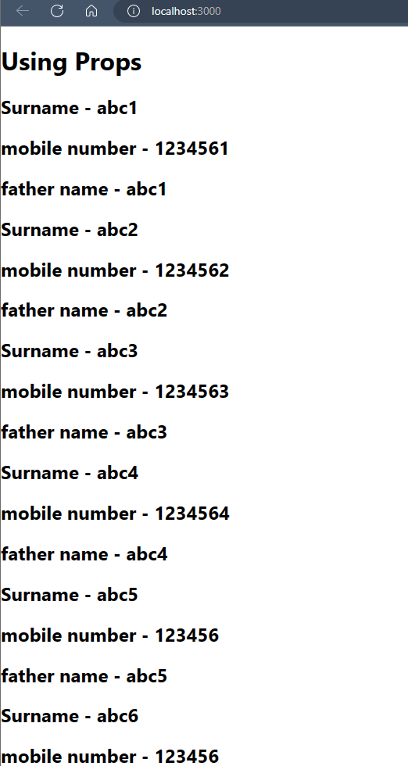

App.js

import React from 'react'

import Sahil from './Sahil'

export default function App() {

  return (

    <div>

      <h1> Using Props </h1>

      < Sahil surname={"abc1"} mobile={1234561} father=

      {"abc1"} />

      < Sahil surname={"abc2"} mobile={1234562} father=

      {"abc2"} />

      < Sahil surname={"abc3"} mobile={1234563} father=

      {"abc3"} />

      < Sahil surname={"abc4"} mobile={1234564} father=

      {"abc4"} />

      < Sahil surname={"abc5"} mobile={123456} father=

      {"abc5"} />

      < Sahil surname={"abc6"} mobile={123456} father=

      {"abc6"} />

      < Sahil surname={"abc7"} mobile={123456} father=

      {"abc7"} />

      < Sahil surname={"abc8"} mobile={123456} father=

      {"abc8"} />

      < Sahil surname={"abc9"} mobile={123456} father=

      {"abc9"} />

      < Sahil surname={"abc10"} mobile={123456} father=

      {"abc10"} />

    </div>

  )

Sahil.js

function Sahil(Props){

    return(

        <div>

            <h2>Surname - {Props.surname}</h2>

            <h2>mobile number  - {Props.mobile}</h2>

            <h2>father name - {Props.father}</h2>

        </div>

    )

}

export default Sahil;

**2. Create a function called YOURNAME_GITAM and pass the Props as Surname, Mobile-Number, Father name .**

**Enter the minimum 10 values for the Props in App.js and Execute the application. This has to be done using Class Component.**

**App.js**

import React from 'react'

import Sahil1 from './Sahil'

export default function App() {

  return (

    <div>

      <h1> Using Props </h1>

      < Sahil1 surname={"abc1"} mobile={1234561} father=

      {"abc1"} />

      < Sahil1 surname={"abc2"} mobile={1234562} father=

      {"abc2"} />

      < Sahil1 surname={"abc3"} mobile={1234563} father=

      {"abc3"} />

      < Sahil1 surname={"abc4"} mobile={1234564} father=

      {"abc4"} />

      < Sahil1 surname={"abc5"} mobile={123456} father=

      {"abc5"} />

      < Sahil1 surname={"abc6"} mobile={123456} father=

      {"abc6"} />

      < Sahil1 surname={"abc7"} mobile={123456} father=

      {"abc7"} />

      < Sahil1 surname={"abc8"} mobile={123456} father=

      {"abc8"} />

      < Sahil1 surname={"abc9"} mobile={123456} father=

      {"abc9"} />

      < Sahil1 surname={"abc10"} mobile={123456} father=

      {"abc10"} />

    </div>

  )

}

**Sahil1.js**

import React, { Component } from 'react'

export default class Sahil1 extends Component {

  render() {

    return (

        <div>

        <h2>Surname - {Props.surname}</h2>

        <h2>mobile number  - {Props.mobile}</h2>

        <h2>father name - {Props.father}</h2>

        </div>

    )

  }

}

